Regulatory Committee
Meeting to be held on 13 January 2016

Electoral Division affected:
Ribble Valley North East

Wildlife and Countryside Act 1981
Definitive Map Modification Order Investigation
Addition of public footpath from Clitheroe Road to Chapel Lane, West Bradford, Ribble Valley
File No. 804-500
(Annex ‘A’ refers)

Contact for further information:
Megan Brindle, 01772 535604, Paralegal Officer, Legal and Democratic Services, megan.brindle@lancashire.gov.uk
Jayne Elliott, 07917 836626, Planning & Environment Group, Public Rights of Way, jayne.elliott@lancashire.gov.uk

Executive Summary

Application for a public footpath from Clitheroe Road to Chapel Lane, West Bradford, Ribble Valley in accordance with file no. 804-500.

Recommendation

1. That the application for a public footpath from Clitheroe Road to Chapel Lane, West Bradford, in accordance with file no. 804-500, be accepted.

2. That an Order(s) be made pursuant to Section 53 (2)(b) and Section 53 (3)(c)(i) the Wildlife and Countryside Act 1981 to add a public footpath from Chapel Lane to Clitheroe Road on the Definitive Map and Statement of Public Rights of Way as shown on Committee Plan between points A-B-C-D-E-F.

3. That being satisfied that the higher test for confirmation can be met the Order be promoted to confirmation.

Background

An application under Schedule 14 of the Wildlife and Countryside Act 1981 has been received for the addition of a public footpath from Clitheroe Road to Chapel Lane for a distance of approximately 75 metres and shown on the Committee plan between points A-B-C-D-E-F on the Definitive Map and Statement of Public Rights of Way.

The County Council is required by law to investigate the evidence and make a decision based on that evidence as to whether a public right of way exists, and if so its status. Section 53(3)(b) and (c) of the Wildlife and Countryside Act 1981 set out the tests that need to be met when reaching a decision; also current Case Law needs to be applied.

An order will only be made to add a public right of way to the Definitive Map and Statement if the evidence shows that:
- A right of way “subsists” or is “reasonably alleged to subsist”

An order for adding a way to or upgrading a way shown on the Definitive Map and Statement will be made if the evidence shows that:
- “the expiration… of any period such that the enjoyment by the public…raises a presumption that the way has been dedicated as a public path or restricted byway”

When considering evidence, if it is shown that a highway existed then highway rights continue to exist (“once a highway, always a highway”) even if a route has since become disused or obstructed unless a legal order stopping up or diverting the rights has been made. Section 53 of the Wildlife and Countryside Act 1981 (as explained in Planning Inspectorate’s Advice Note No. 7) makes it clear that considerations such as suitability, the security of properties and the wishes of adjacent landowners cannot be considered. The Planning Inspectorate’s website also gives guidance about the interpretation of evidence.

The County Council’s decision will be based on the interpretation of the evidence discovered by officers and documents and other evidence supplied by the applicant, landowners, consultees and other interested parties produced to the County Council before the date of the decision. Each piece of evidence will be tested and the evidence overall weighed on the balance of probabilities. It is possible that the Council’s decision may be different from the status given in any original application. The decision may be that the routes have public rights as a footpath, bridleway, restricted byway or byway open to all traffic, or that no such right of way exists. The decision may also be that the routes to be added or deleted vary in length or location from those that were originally considered.

Consultations

Ribble Valley Borough Council

The Council has been consulted and confirm that they hold no supporting evidence either in support or against the application.

West Bradford Parish Council

West Bradford Parish Council are the applicant for this application and therefore support it.

Applicant/Landowners/Supporters/Objectors

The evidence submitted by the applicant/landowners/supporters/objectors and observations on those comments are included in Advice – Head of Service – Legal and Democratic Services Observations.

Advice

Head of Service – Planning and Environment

Points annotated on the attached Committee plan.

Point | Grid Reference (SD) | Description
A | 7436 4435 | Open junction with Clitheroe Road
B | 7438 4435 | Adjacent to south west corner of rear of 25 Millbrook Court
C | 7439 4435 | Top of flight of steps adjacent to rear of 23 Millbrook Court
D | 7440 4435 | Rear of 22 Millbrook Court
E | 7441 4436 | Adjacent to garage building
F | 7443 4437 | Open junction with Chapel Lane

Description of Route

A site inspection was carried out on 24 November 2015.

The route under investigation ('the route') commences at a junction with Clitheroe Road immediately north of Mill Bridge (point A on the Committee plan). From point A it passes in a south easterly direction over the tarmac surface bounded by 26 Millbrook Court (Overbrook House) and the stone wall adjacent to the watercourse known as West Bradford Brook at a width of 3 metres tapering to 2.2 metres after 3.5 metres. Within this area a car was parked when the route was inspected although it was possible to walk past the car to continue along the route. Beyond the parked car and extending out from 26 Millbrook Court a stone wall has been constructed alongside the route behind which is a small triangular shaped garden between 26 and 25 Millbrook Court. The route is approximately 90cm wide for a distance of 10 metres as it passes between the stone wall adjacent to the watercourse and the wall constructed to provide the triangular gardens forming part of the 2 properties.

The route narrows to approximately 60cm where it passes between the stone wall adjacent to the watercourse and the southern corner of 25 Millbrook Court (point B). It then turns to continue in a more east north easterly direction adjacent to the rear of 25 and 24 Millbrook Court from where pedestrian access into the grounds of Millhouse is available. 25 and 26 Millbrook Court also have rear doors which open directly onto the route. From point B for approximately 6 metres the route fans out to a width of 3.5m at its widest point and then narrows to approximately 1.1m at the foot of a series of concrete steps between Millhouse and the rear of 24 and 23 Millbrook Court.

The route ascends the 12 concrete steps at the top of which (point C) there is a rear door providing access onto the route from 23 Millbrook Court. It then follows an enclosed route around the rear of Millhouse bounded to the south by the building and to the north by garden fencing to the rear of 23 and 22 Millbrook Court at a width varying between approximately 1 and 1.1 metres to point D from where it continues in a generally north easterly direction enclosed by a substantial stone wall and garage building to the south and garden fences to the rear of properties 18, 19 and 20 Millbrook Court to the north. The properties along Millbrook Court all have wooden gates from the gardens that open out onto the route and on the day that the route was inspected three refuse bins were situated along the route which it was possible to walk around. The route between point D and point E varied in width between approximately 1 and 1.5 metres.

The route passes the end of the stone garage (point E) and continues in a generally north easterly direction for a further 20 metres to the rear of 19, 18 and 17 Millbrook Court to point F where it exits onto Chapel Lane.

The total length of the route is 75 metres.

When the route was inspected in 2015 it was accessible on foot along the full length. No signs were evident indicating whether the route was considered to be public or private and it was noted that all of the adjacent properties had direct access onto the route and that a number of them stored their rubbish bins along it.

Map and Documentary Evidence

Document Title | Date | Brief Description of Document & Nature of Evidence
Jeffreys' Map of Yorkshire | 1772 | Small scale commercial map. Jeffery's' Map of Yorkshire was published in 1775 at a scale of 1 inch: 1 mile. It was originally surveyed from 1767-1770, 69 and a half miles to 1 degree (approx.). It was published in a book of 42 leaves by act of parliament dated 25 Mar 1772.
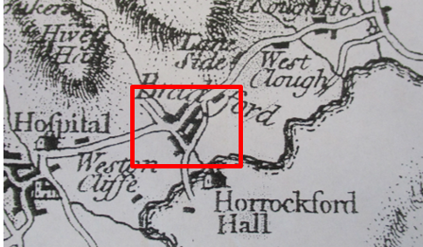
Observations |  | The route is not shown. Clitheroe Road and Chapel Lane are shown and a watercourse can be seen passing through the village. Buildings appear to have existed in the proximity of the route.
Investigating Officer's Comments |  | A route claimed as a public footpath would be unlikely to be shown on the map due to the limitations of scale and the purpose for which it was drawn. No inference can be drawn.
Teesdale's Map of Yorkshire | 1828 | Small scale commercial map at a scale of 7½ inches to 1 mile.
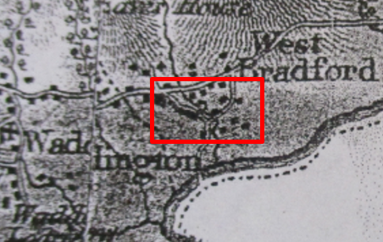
Observations |  | The route is not shown. Clitheroe Road and Chapel Lane are shown and a watercourse can be seen passing through the village. Buildings appear to have existed in the proximity of the route.
Investigating Officer's Comments |  | A route claimed as a public footpath would be unlikely to be shown on the map due to the limitations of scale and the purpose for which it was drawn. No inference can be drawn.
Canal and Railway Acts |  | Canals and railways were the vital infrastructure for a modernising economy and hence, like motorways and high speed rail links today, legislation enabled these to be built by compulsion where agreement couldn't be reached. It was important to get the details right by making provision for any public rights of way to avoid objections but not to provide expensive crossings unless they really were public rights of way. This information is also often available for proposed canals and railways which were never built.
Observations |  | No canals or railways are known to be proposed or constructed over the area crossed by the route under investigation.
Investigating Officer's Comments |  | No inference can be drawn.
Tithe Map and Tithe Award or Apportionment | 1848 | Maps and other documents were produced under the Tithe Commutation Act of 1836 to record land capable of producing a crop and what each landowner should pay in lieu of tithes to the church. The maps are usually detailed large scale maps of a parish and while they were not produced specifically to show roads or public rights of way, the maps do show roads quite accurately and can provide useful supporting evidence (in conjunction with the written Tithe Award) and additional information from which the status of ways may be inferred.
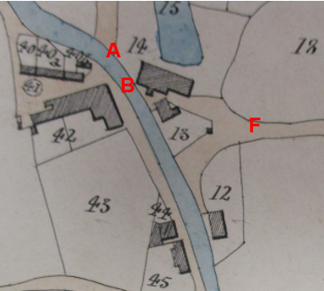
Observations |  | The parish copy of the Tithe Map and Award were inspected at the County Records Office.  Clitheroe Road is shown without a bridge or ford crossing adjacent to point A. From point A the route is not shown but would cross open land forming part of plot 14. The Tithe Award lists the owner and occupier of plot 14 as Samuel Ashton Esq. and it is described in the Award as 'mill and land'. From point B through to point F a shaded route appears to be accessible which is wider than the current route but which Is consistent with it. The shaded area reaches the brook. It is abutted on the south side by the building that forms part of plot 13 - Millhouse - which still exists today and is listed in the Award as being owned by John Williamson and owned by William Hindle and on the north side by a mill building.
Investigating Officer's Comments |  | It is not specified on the Tithe Map whether a ford existed across the watercourse to connect the two parts of Clitheroe Road but it is reasonable to assume that it did. Similarly there is no crossing shown at point B despite the shaded road running from Chapel Lane to the edge of the brook. Between point A and B the route is not shown or referred to in the Tithe Award but access may have been available to point B to avoid crossing the watercourse. Between point B and point F an area is shown shaded which is not included in any of the numbered plots and which is coloured in the same way as other roads through the village. The shading would appear to denote a public route. The area shaded is much wider than the claimed route but would incorporate within the width the route now under investigation. The route may have existed between point A and point B and existed as a wider route between point B and point F in 1848.
Inclosure Act Award and Maps |  | Inclosure Awards are legal documents made under private acts of Parliament or general acts (post 1801) for reforming medieval farming practices, and also enabled new rights of way layouts in a parish to be made. They can provide conclusive evidence of status.
Observations |  | There is no Inclosure Award for West Bradford deposited in the County Records Office.
Investigating Officer's Comments |  | No inference can be drawn.
6 Inch Ordnance Survey (OS) Map | 1850 | The earliest Ordnance Survey 6 inch map for this area surveyed in 1847 and published in 1850.
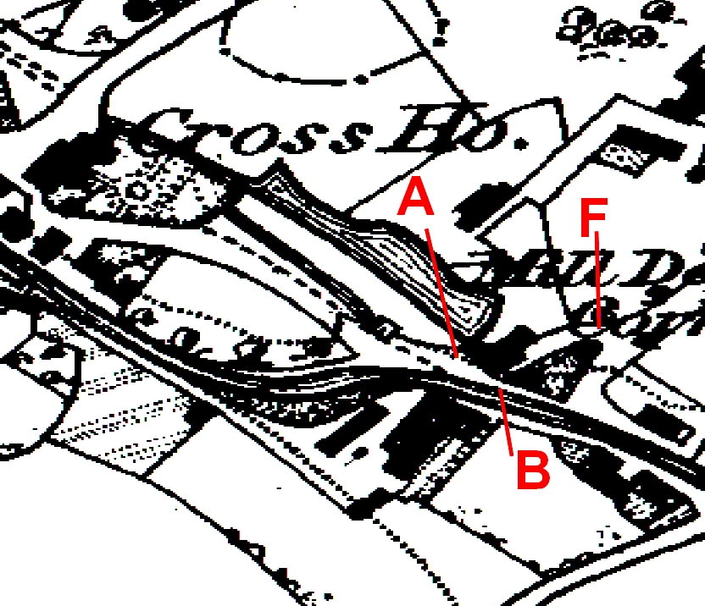
Observations |  | The scale of the map makes it difficult to see clearly whether the route under investigation existed. There is no bridge across the stream for Clitheroe Road. The route is not clearly shown but a gap does appear to exist between corn mill and Millhouse suggesting access may have been available. A-B has a broken line separating it from the road.
Investigating Officer's Comments |  | The route may have existed in 1850 and may have offered a useful alternative to fording the watercourse close to point A or B. A-B appears to be accessible (a broken line denotes a change in surface or similar feature which would not prevent pedestrian access.
25 Inch OS Map | 1886 | The earliest OS map at a scale of 25 inch to the mile. Surveyed in 1883-84 and published in 1886.
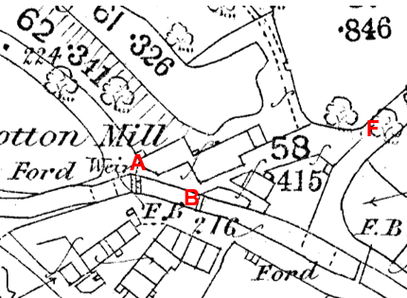
Observations |  | The way past the mill buildings has changed but the route under investigation can be clearly seen to exist as a wider route than the one that exists today. Clitheroe Road was traversed via a ford crossing a little to the west of point A. The building adjacent to point A which now forms 26 Millbrook Court is shown and across the route at point A a dashed line can be seen which may indicate a change in surface. A wide and open route can be seen alongside the brook from point A to point B and continuing between the buildings to point F. There is a footbridge at B
Investigating Officer's Comments |  | The route under investigation probably existed in 1886. The footbridge at B suggests that pedestrians could cross the brook via the bridge then either continue ahead to or through the mill towards the chapel or turn left towards the post office. The mill had changed ownership in 1867, according to The Lancashire Village Book, when the Holgate family took it over and converted it from a corn mill to a cotton mill which closed in 1960.
6 inch OS Map | 1890 | OS 6 inch map surveyed 1847, revised in 1884 and published in 1890.
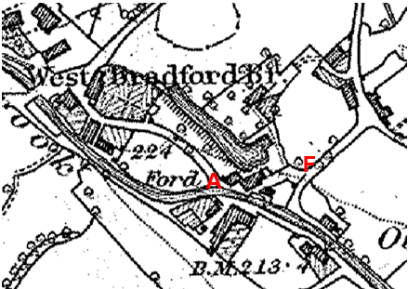
Observations |  | The route under investigation is shown as a wider route between the buildings. Access at point A appears open and available and access in the proximity of point F also appears to be open. No footbridge is shown.
Investigating Officer's Comments |  | A wider route than exists today but consistent with the alignment of the route under investigation existed in 1884. The footbridge shown on the 25 inch map did not exist in 1847 when this was surveyed and appears not to have been included in the 1884 revision.
25 inch OS Map | 1912 | Further edition of the 25 inch map surveyed in 1893-84, revised in 1907 and published in 1912.
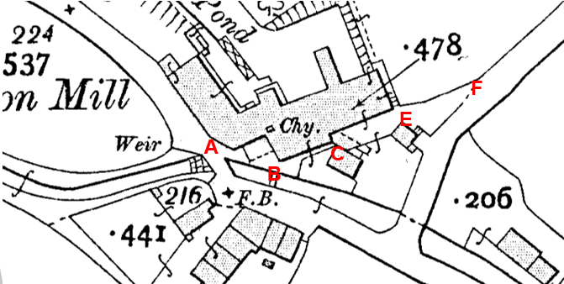
Observations |  | A bridge is shown across the watercourse forming part of Clitheroe Road. The mill appears to have extended in size. Access onto the route is open at point A but midway between point A and point B the route narrows and a line is shown across the route. A further line is shown across the route at point C and immediately beyond point C is a shaded area which may have restricted or prevented access. Access to the route at point E appears to be available. The footbridge is still shown at B.
Investigating Officer's Comments |  | The route under investigation may have been accessible in 1907 but appears less clear than on earlier OS maps prior to the erection of the bridge forming part of Clitheroe Road. Point B can still be accessed via the footbridge.
Finance Act 1910 Map | 1910 | The comprehensive survey carried out for the Finance Act 1910, later repealed, was for the purposes of land valuation not recording public rights of way but can often provide very good evidence. Making a false claim for a deduction was an offence although a deduction did not have to be claimed so although there was a financial incentive a public right of way did not have to be admitted.  Maps, valuation books and field books produced under the requirements of the 1910 Finance Act have been examined. The Act required all land in private ownership to be recorded so that it could be valued and the owner taxed on any incremental value if the land was subsequently sold. The maps show land divided into parcels on which tax was levied, and accompanying valuation books provide details of the value of each parcel of land, along with the name of the owner and tenant (where applicable).  An owner of land could claim a reduction in tax if his land was crossed by a public right of way and this can be found in the relevant valuation book. However, the exact route of the right of way was not recorded in the book or on the accompanying map. Where only one path was shown by the Ordnance Survey through the landholding, it is likely that the path shown is the one referred to, but we cannot be certain. In the case where many paths are shown, it is not possible to know which path or paths the valuation book entry refers to. It should also be noted that if no reduction was claimed this does not necessarily mean that no right of way existed.
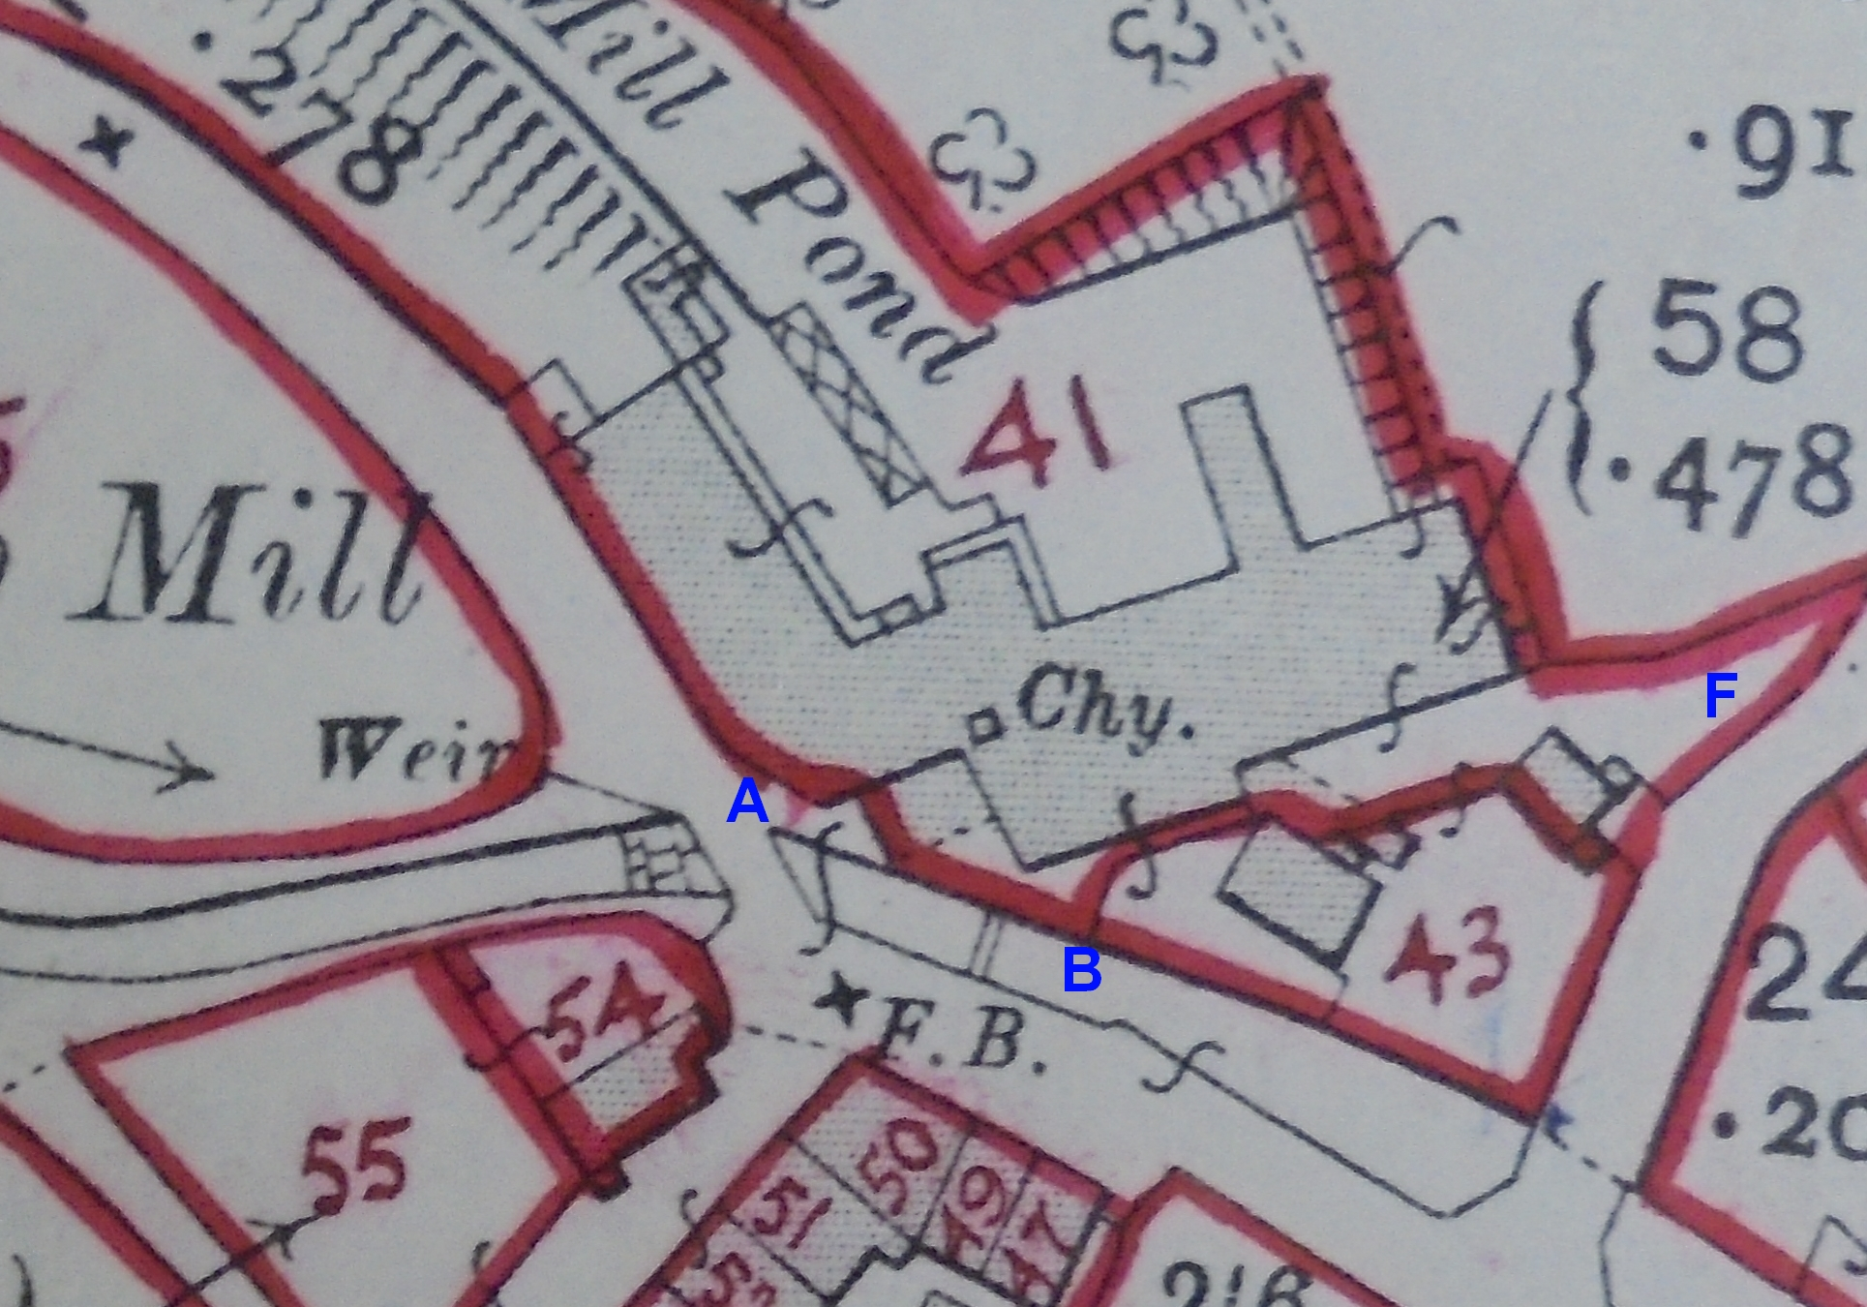
Observations |  | The Finance Act records were examined at the National Archives. The Finance Act plan shows the majority of the route forming part of plot 41. The Valuation Book held in the County Records Office lists the owner and occupier of plot 41 as John Holgate and describes the property as 'mill'. No deductions are listed for public rights of way or user. Part of the route, south east from point A, is excluded from numbered hereditaments as though part of Clitheroe Road.  Plot 43 is listed as being owned and occupied by Robert Holgate and the property described as 'Mill House'. No deduction is made for public rights of way or user.
Investigating Officer's Comments |  | The application route probably did not exist or was not considered to be a public right of way circa 1910 or a deduction was not considered worth claiming. The short section south east from point A was probably considered to be part of the highway.
6 Inch OS Map | 1934 | Further edition of 6 inch map revised in 1930 and published 1934.
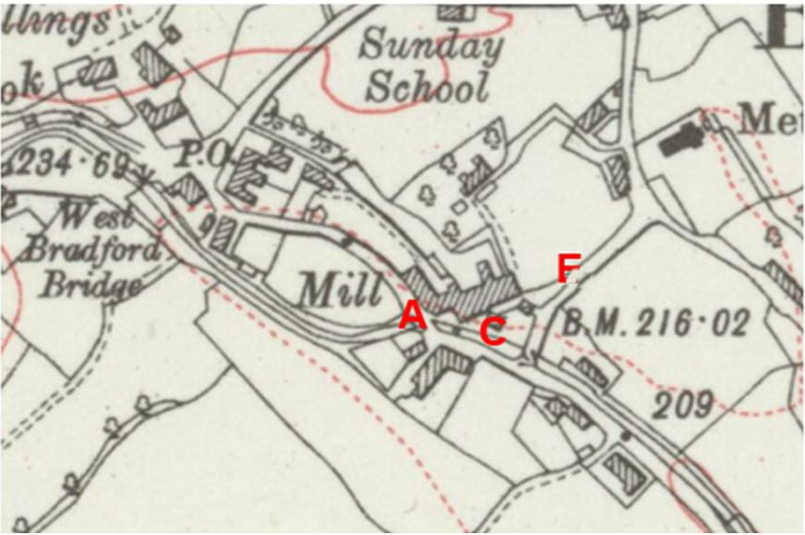
Observations |  | The route appears accessible between point A and point F although it is not possible to determine, due to the scale of the map, whether a gap existed between the buildings at point C.
Investigating Officer's Comments |  | The route may have existed in 1930.

Aerial Photograph | 1940s |  | The earliest set of aerial photographs available was taken just after the Second World War in the 1940s and can be viewed on GIS. The clarity is generally very variable.
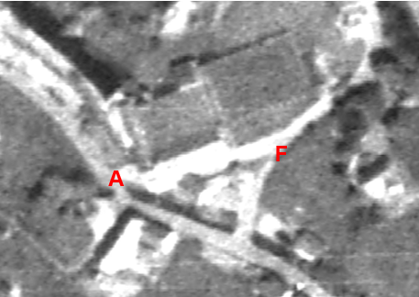
Observations |  |  | The quality of the aerial photograph is poor and it is not possible to determine whether the route under investigation existed.
Investigating Officer's Comments |  |  | No inference can be drawn.
Photos |  | N/K | 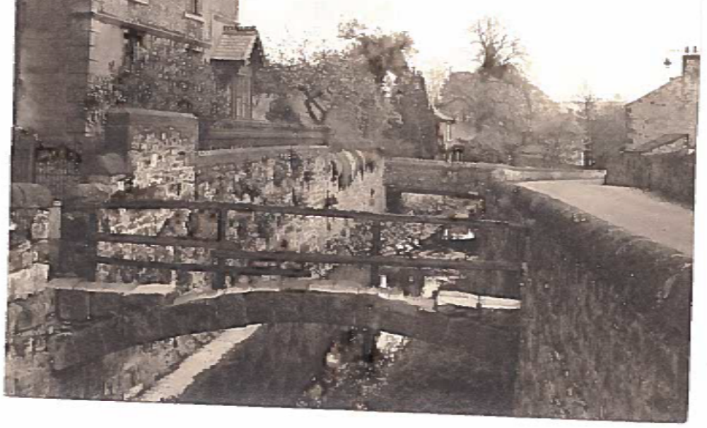
Observations |  |  | The bridge, known as Cat Bridge, consisted of a single arch of blocks with some infill at either end and a wooden parapet. The parapet appears to be in disrepair.
Investigating Officer's Comments |  |  | Pedestrian access, albeit somewhat precarious by today's standards, was provided from the road on the west of the brook to the vicinity of the mill on the east.
Corresp-ondence betweenBowland Rural District Council, West Riding County Council and West Bradford Parish Council |  | 1949-1955 | 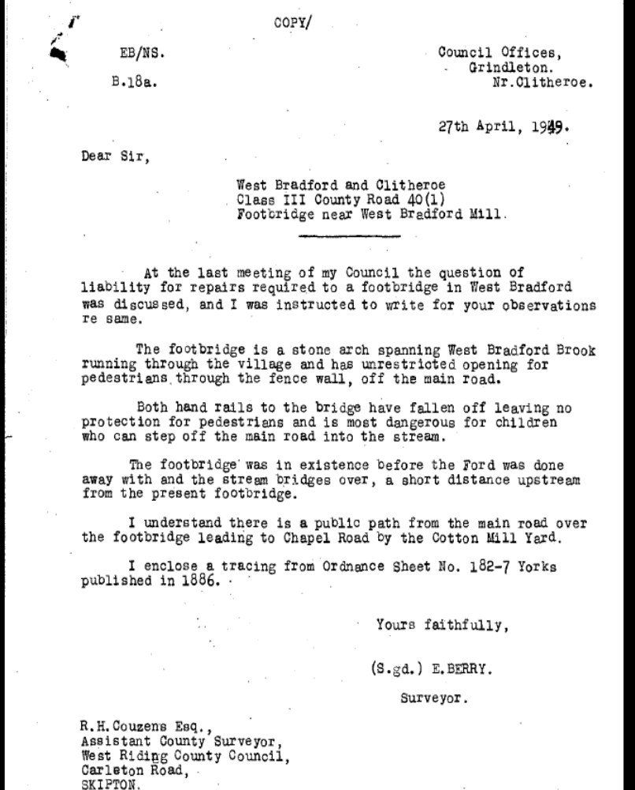  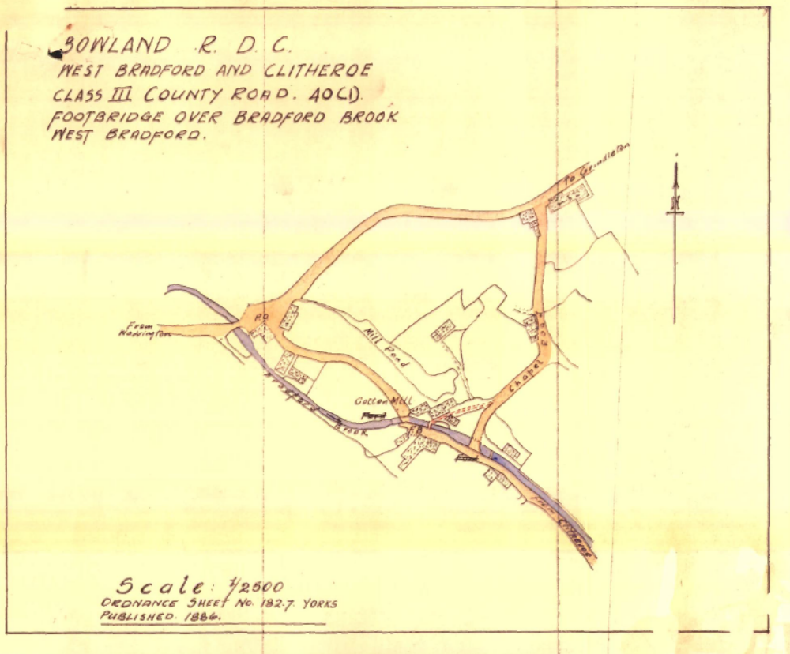
Observations |  |  | The District Surveyor says to County Surveyor that he understands the route B-F to be a public path, i.e. from the east end of the footbridge. The traced map has been shaded, it is clear from another letter that this was by the County, to show the path red, as distinct from roads (brown) and brook (blue).  Further correspondence shows that the footbridge was out of repair and the parapets fallen off by 1949 but none of the councils would take maintenance responsibility so the ends of the bridge were stopped up in 1955, apparently without protest from users.
Investigating Officer's Comments |  |  | The RDC was responsible for public paths until 20 years before this letter so probably would have relevant knowledge of long standing public paths such as this. Both County and District suggested that if the Parish thought it to be a public path they should have included it in the survey for the National Parks and Access to the Countryside Act 1949. The fact that the bridge was not considered to be publicly maintainable does not mean that there was not a public right of way over it.

6 Inch OS Map | 1955 | The OS base map for the Definitive Map, First Review, was published in 1955 at a scale of 6 inches to 1 mile (1:10,560). This map was revised before 1930 and is probably based on the same survey as the 1930s 25-inch map.
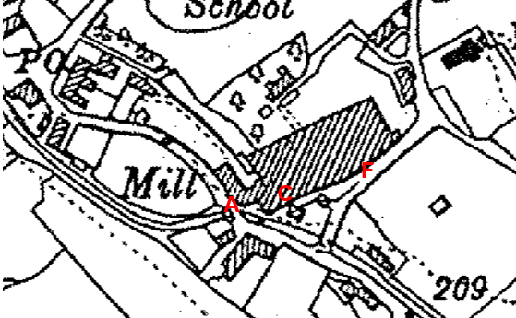
Observations |  | The route under investigation appears to be accessible as part of a wider route between the mill buildings and Millhouse although it is not possible to see – due to the scale of the map – whether access was available between the buildings at point C. The footbridge is not indicated but there is a 'blob' on the map in the stream at that location
Investigating Officer's Comments |  | The route under investigation may have existed in the 1930s (date of survey).
Conveyance Plan | 1962 | 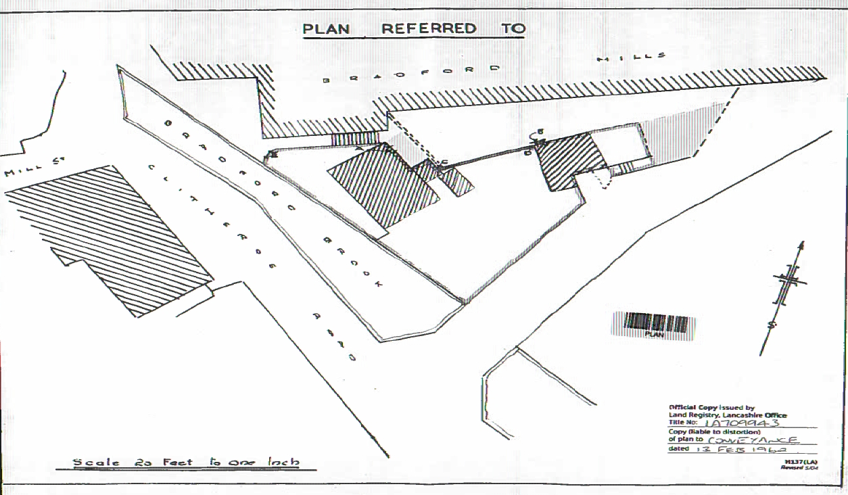
Observations |  | The route is shown open with no solid lines across it, a broken line at point F where it meets the Chapel Lane, a double dashed line between the old mill and Millhouse and with a flight of steps at the narrowest point.
Investigating Officer's Comments |  | This conveyance is dated 1962, i.e. 2 years after the cotton mill closed. A private right of access was reserved from the top left of the above plan south west alongside the brook to the point annotated E (which corresponds to A-B on the route under investigation). Although there could be some implication that this was therefore not considered public at the time it does not preclude it because it provides greater security and certainty for the property owner to have their private rights recorded. It does suggest that the way was physically passable.

1:2500 OS Map | 1969 | Further edition of 25 inch map reconstituted from former county series and revised in 1967 and published in 1969 as national grid series.
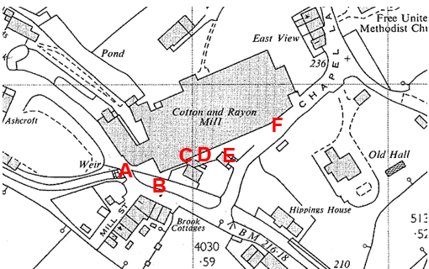
Observations |  | Access along the route under investigation appears to be available between points A-B-C. A line is shown across the route at point C and immediately beyond point C a shaded area can be seen indicating some sort of physical structure. Access along the route appears available from point D to point E. The footbridge is not shown.
Investigating Officer's Comments |  | The route under investigation existed between points A-B-C and D-E-F but it is uncertain from the Ordnance Survey map whether access was available between point C and point D. The footbridge no longer existed at point B which is consistent with an online history of the village stating it was destroyed by a flood in 1958.

Aerial photograph | 1960s | The black and white aerial photograph taken in the 1960s and available to view on GIS.
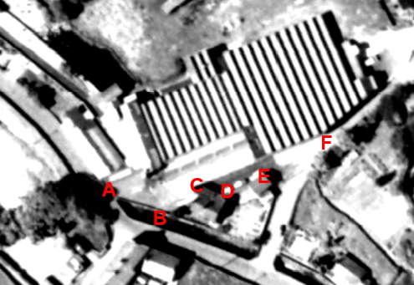
Observations |  | The Mill is shown and Millhouse and the building adjacent to point E can be seen. Vehicles appear to be parked along the line of the route between point D and point E. It is not possible to see from the aerial photograph whether access was available along the full length of the route – particularly between point B-C-D-E.
Investigating Officer's Comments |  | The route would have passed through the entrance area of the mill, which changed function in the early 1960s. The scale of the photograph means that it is not possible to determine whether access was available along the route.
1:2500 OS Map | 1977 | Further edition of OS mapping revised 1976 and published 1977.
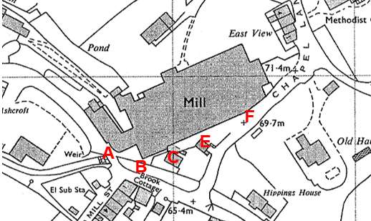
Observations |  | Access along the route under investigation appears to be available between points A-B-C. A line appears to exist across the route at point C and immediately beyond point C a shaded area can be seen indicating some sort of physical structure. Access along the route appears available from point D to point E. working mill.
Investigating Officer's Comments |  | The route under investigation existed between points A-B-C and D-E-F but it is uncertain from the Ordnance Survey map whether access was available between point C and point D in 1976.
Aerial Photograph | 2000 | Aerial photograph available to view on GIS.
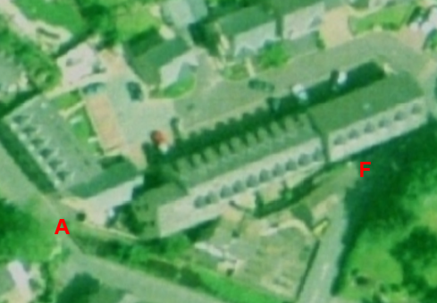
Observations |  | By 2000 the mill buildings to the north of the route had been partly demolished and redeveloped into residential dwellings. The scale of the photograph, tree coverage and shadows mean that when it is enlarged it is not possible to see whether the route under investigation exists.
Investigating Officer's Comments |  | The area to the north of the route under investigation has been redeveloped but no inference can be drawn from the photograph with regards to whether the route was available to use in 2000.
Definitive Map Records |  | The National Parks and Access to the Countryside Act 1949 required all highway authorities to prepare a Definitive Map and Statement of Public Rights of Way.  At the time that the Definitive Maps were originally prepared the parish of West Bradford was part of Bowland Rural District in the West Riding of Yorkshire.  When the area became part of Lancashire as part of the Local Government reorganisation in 1974 records relating to the preparation of the Definitive Map were passed to Lancashire County Council and the current record – the Revised Definitive Map and Statement (First Review) was prepared.
Parish Survey Map | 1950-1952 | The initial survey of public rights of way was carried out by the parish council in those areas formerly comprising a rural district council area and by an urban district or municipal borough council in their respective areas. Following completion of the survey the maps and schedules were submitted to the County Council. In the case of municipal boroughs and urban districts the map and schedule produced, was used, without alteration, as the Draft Map and Statement. In the case of parish council survey maps, the information contained therein was reproduced by the County Council on maps covering the whole of a rural district council area. Survey cards, often containing considerable detail exist for most parishes but not for unparished areas.
Observations |  | The County Council does not have the parish survey maps that were originally prepared for the parishes of West Bradford.

Draft Map |  | The parish survey map and cards for West Bradford were handed to West Riding of Yorkshire County Council who then considered the information and prepared the Draft Map and Statement.  The Draft Maps were given a “relevant date” (22nd September 1952) and notice was published that the draft map for the West Riding of Yorkshire had been prepared. The draft map was placed on deposit for a minimum period of 4 months on 6th June 1953 for the public, including landowners, to inspect them and report any omissions or other mistakes. Hearings were held into these objections, and recommendations made to accept or reject them on the evidence presented.
Observations |  | The route under investigation was not shown on the Draft Map and no representations were made to the County Council.
Provisional Map |  | Once all representations relating to the publication of the draft map were resolved, the amended Draft Map became the Provisional Map which was published in 1970, and was available for 28 days for inspection. At this stage, only landowners, lessees and tenants could apply for amendments to the map, but the public could not. Objections by this stage had to be made to the Crown Court.
Observations |  | The route under investigation was not shown on the Draft Map and no representations were made to the County Council.
The First Definitive Map and Statement |  | The Provisional Map, as amended, was published as the Definitive Map in 1973.
Observations |  | The route under investigation was not shown on the Draft Map and no representations were made to the County Council.
Revised Definitive Map of Public Rights of Way (First Review) |  | Legislation required that the Definitive Map be reviewed, and legal changes such as diversion orders, extinguishment orders and creation orders be incorporated into a Definitive Map First Review. On 25th April 1975 (except in small areas of the County) the Revised Definitive Map of Public Rights of Way (First Review) was published by Lancashire County Council with a relevant date of 1st September 1966. This Map included the parish of West Bradford which now formed part of Lancashire although this would have had a relevant date inherited from West Riding. No further reviews of the Definitive Map have been carried out. However, since the coming into operation of the Wildlife and Countryside Act 1981, the Definitive Map has been subject to a continuous review process.
Observations |  | The route under investigation is not shown on the Revised Definitive Map of Public Rights of Way (First Review) and Statement.
Investigating Officer's Comments |  | From 1952 through to 1973 there is no indication that the route under investigation was considered to be public right of way by the Surveying Authority. There were no objections or representations made with regards to the fact that the route was not shown on the map when the maps were placed on deposit for inspection at any stage of the preparation of the Definitive Map.
Highway Adoption Records including maps derived from the '1929 Handover Maps' | 1929 to present day | In 1929 the responsibility for district highways passed from district and borough councils to the County Council. For the purposes of the transfer, public highway 'handover' maps were drawn up to identify all of the public highways within the county. These were based on existing Ordnance Survey maps and edited to mark those routes that were public. However, they suffered from several flaws – most particularly, if a right of way was not surfaced it was often not recorded.  A right of way marked on the map is good evidence but many public highways that existed both before and after the handover are not marked. In addition, the handover maps did not have the benefit of any sort of public consultation or scrutiny which may have picked up mistakes or omissions.  The County Council is now required to maintain, under section 31 of the Highways Act 1980, an up to date List of Streets showing which 'streets' are maintained at the public's expense. Whether a road is maintainable at public expense or not does not determine whether it is a highway or not.
Observations |  | The route under investigation is not recorded as being publicly maintainable in the records originally derived from the 1929 Handover Maps and now held by the County Council.
Investigating Officer's Comments |  | The route under investigation was not recorded as a publicly maintained highway in 1929. However, many public rights of way have been found not to have been recorded on these maps – often if they were unsurfaced at that time so the fact that the route was not recorded as being publicly maintainable does not necessarily mean that it wasn't.
Statutory deposit and declaration made under section 31(6) Highways Act 1980 |  | The owner of land may at any time deposit with the County Council a map and statement indicating what (if any) ways over the land he admits to having been dedicated as highways. A statutory declaration may then be made by that landowner or by his successors in title within ten years from the date of the deposit (or within ten years from the date on which any previous declaration was last lodged) affording protection to a landowner against a claim being made for a public right of way on the basis of future use (always provided that there is no other evidence of an intention to dedicate a public right of way).  Depositing a map, statement and declaration does not take away any rights which have already been established through past use. However, depositing the documents will immediately fix a point at which any unacknowledged rights are brought into question. The onus will then be on anyone claiming that a right of way exists to demonstrate that it has already been established. Under deemed statutory dedication the 20 year period would thus be counted back from the date of the declaration (or from any earlier act that effectively brought the status of the route into question).
Observations |  | No Highways Act 1980 Section 31(6) deposits have been lodged with the County Council for the area over which the route under investigation runs.
Investigating Officer's Comments |  | There is no indication by a landowner under this provision of non-intention to dedicate public rights of way over their land.

The affected land is not designated as access land under the Countryside and Rights of Way Act 2000 and is not registered common land.

Landownership

Affected landowners:

Whalley Developments Limited
18 Millbrook Court
20 Millbrook Court
21 Millbrook Court
22 Millbrook Court
23 Millbrook Court
24 Millbrook Court
25 Millbrook Court
26 Millbrook Court

Possible Affected landowners:

17 Millbrook Court
19 Millbrook Court
Millhouse Clitheroe Road

In the title documents there is reference to the sale by the Mill of the house to the south of the claimed route (Millhouse) and the purchaser being granted a private right of way to access Clitheroe Road at point A. the right of way was said to be on foot over the Vendors adjoining land.

Summary

Early maps and records examined show a substantial route passing between the Mill and Millhouse much wider than now available but along a similar alignment. This route appeared to provide a link prior to the construction of the bridge on Clitheroe Road and between point B and point F the route was shown shaded on the Tithe Map of 1848, consistent with the highway network.

Before the road bridge was built there was a narrow footbridge, the 'Cat Bridge', over West Bradford Brook from the road on the west side to the route between the mill buildings and shown as highway on the Tithe Map and also along the east bank to the road avoiding the ford. This footbridge appears to have been built around the time that the old corn mill was converted to a cotton mill by its new owner who bought it in 1867. There were other changes to the brook around that time which may have affected accessibility between the 2 banks.

No Finance Act 1910 documentary evidence supports the existence of a public route except for the short section alongside the brook near point A and no deduction for a public right of way was claimed in relation to the remainder of the route.

The OS map evidence is inconclusive regarding whether the route remained accessible from 1912 onwards and was possibly gated or physically restricted between points C and D prior to 1962 when the conveyance plan shows it clear.

By 1949 the road bridge had been widened making it safer for pedestrians to use and the Cat Bridge had deteriorated and its wooden parapets fallen off making it only suitable for agile pedestrians. It was blocked off, for safety reasons, in 1955 and was destroyed by flood water in 1958.

Following redevelopment of the old mill into residential properties the width of route appears to have been significantly reduced between point C and F to provide back yard/gardens to the properties although a useable through route retained which all the properties abutting it appear to have direct access to.

Head of Service – Legal and Democratic Services Observations

Information from the Applicant

In support of the application, the applicant has provided 5 user evidence forms in support of the application, these forms were filled in in 2009.

The amount of years in which the users have known the route varies from, 35, 42, 50, 60 and 69 years.
All 5 users have used the route on foot. 2 users specified using the route between 1966-2009 and 1940-1959 & 1997-2007, the other 3 users responded with 'until access denied by locked gates', 'I make a point of using it about 4 times a year', and 'up to when gates were put on and locked'.

The main places the users were going to and from include Chapel Lane to Clitheroe Road, Chapel Lane to Mill Street Bridge into the village and to Grindleton Road. The main purpose for the users using the route include delivering papers and visiting friends, visiting the chapel, cutting off the main road route and for social reasons.
The use of the route per year varies from 'quite often', 'sometimes daily', a minimum of 4, 'many times', 'numerous' and 20 times.

None of the users have ever used the route on horseback or motorcycle / vehicle or by way of any other means. And all 5 users have seen others using the way on foot.

2 users agree that the route has always run over the same line, 1 user states it has until the mill was converted into houses, and another states yes until the bridge was washed away and another states they walked up cat bridge 1955.

2 users didn’t reply when asked if there are any stiles / gates or fences along the route, 1 user states 'one of the residents in the mill put a gate across the top of the shops for child safety' another mentions 'gates with locks now deny access' and the other user states 'gates with padlocks across the right of way'. 2 users agree that gates were locked across the route and the same 2 users agree they have been prevented access from using the route.

All 5 users have either never worked for a landowner or a tenant of the route or did not provide a response to this question.
None of the users have ever been stopped when using the way but 1 user did state they were disappointed when access was denied and no one has ever heard of anyone else having been stopped or turned back when using the route, however the same user did state that they had some conversations with other local people over the same lack of access.
None of the users have ever been told the route they were using was not a public right of way, nor have they ever seen any signs or notices or asked permission to use the route.

At the end of completing the user evidence form users are asked to provide any further information they feel is necessary, this information is set out below:

- Since wheelie bins were introduced the houses leave them on the footpath instead of their gardens making it difficult sometimes to walk along the path. I have lived and worked in the village for over 40 years and in that time I owned the village shop (newsagents) for nearly 18 years and used the path and steps down this side of the mill (now houses) regularly to deliver papers and as a short cut to Clitheroe Road and still use it now.
- I think the loss of this pathway access removes a very well used old route which gave more character to the village and is a historical feature of the old village.
- Mr Holgates now deceased was part of the family that owned the mill always maintained that this was a public right of way and has written many articles on the history of West Bradford which I believe his daughter Mrs A Pike is in possession of. Rubbish and wheelie bins are obstructing the pathway.
- Mr Herbert Holgate a past resident of West Bradford told me that he always walked through that way to keep the right of way open.

As well as the user evidence forms the applicant has also submitted 2 letters in support of the application, the information from these letters is set out below.

Letter from E Gretton

- Confirms that for over 40 years he and his wife understood this was a public footpath and have walked it frequently.
- They were told about the village path by other local inhabitants after moving to the area in 1967.
- They were told the story of the old "Cat Bridge", a footbridge that used to cross West Bradford Brook and joined the footpath just below its Clitheroe Road end.
- This bridge was washed away in the 1958 flood and was never rebuilt but its location can still be seen.
- A former owner of the mill (Mr Herbert Holgate, now deceased) told him on several occasions that this path had always been a public footpath and he felt it was important that this should be officially recorded so that the path could never be closed by the new owners of the mill who were converting it for residential use.
- Another long-deceased resident of West Bradford Mr Wallace Penman, who had been responsible for maintenance at the mill for much of his life, also told him that although the path lay on land owned by the mill it had always been a public footpath.
- He has been involved in the registration of five different West Bradford Footpaths as public rights of way.
- Reference is made to a report following on from a Parish Council meeting in 1996 about when the path was first blocked and discussion about submitting a Definitive Map Modification application, details have been provided below.
- The path between Beckside and the old Trutex Mill now converted into individual houses has been blocked be a new fence.
- On 28/6/96 it was reported to LCC who were already aware of the problem, but no existing public right of way, therefore a claim form is needed.
- 6/96 Herbery Holgate: It was always a public footpath
Albert Titterington: Always a generally used path but he sees little point in upsetting residents by removing their privacy
- The fence blocking the path had been erected by Mrs Hanson, as her kitchen lay immediately underneath the path and she was concerned that numerous resident's moving into the converted mill would greatly increase the traffic above her head.
- A meeting was held with Mrs Hanson and the solicitor acting for the owners of the mill, when it was agreed that the footpath had long been used by the public and that the fence erected by Mrs Hanson and blocking it, would be removed.
- He has recollection that some concession was made by Mr Taylor on behalf of the owners with regard to widening the path, but does not remember the precise details of this concession.
- Also on his file he has a extract from a report on local footpath developments that were submitted to West Bradford Parish Council on 3 April 1998 that stated:
"Unlisted Footpath between the Old Trutex Mill and Beckside (formerly the Mill House and now owned by Mrs Hanson):
Although not included in the definitive footpath map, this has long been used as a public footpath. When the mill was converted into private houses in 1996 the path was closed for a period because if a dispute about whether the footpath lay over Mrs Hanson's property or through the gardens of the new houses. However this problem appears to have been resolved and the path is open again. Several of the new houses have boundaries adjoining this path and I think that, to avoid the possibility of any dispute, it is important that the path should be formally declared a public footpath and included in the definitive footpath map. I understand that this would normally be done through submission of a claim to the County Council by the Parish Council or a body such as the Ramblers' Association. Many of the people who are familiar with this path are now elderly and, because evidence forms will need to be completed be several such people, the Parish Council may well agree that it would be sensible to act fairly soon on this point."
- A copy of the full report can be available for inspection if required.

Letter from A Pike

- As a resident of "Mill House" now re-named Beckside from 1937-1959, she can confirm the footpath from Chapel Lane to the rear of Beckside was in full use as during that period there was a footbridge now the brook to Mill Street. This was used by many members of the village.
- Photographs of the footbridge provided.
- Also provided a copy of a typed page entitled "Parish of West Bradford" with events noted from 1913 – 1923. This paper has as an entry "Cat Bridge" and says it was "Bridge over brook leading to Mill steps and Mill House, Cat Bridge was one of two bridges over the brook before the highway bridges were built, the other was just above Hippins House. Cat Bridge ended up with no sides, in 1955 both ends were walled up as a means of protection"

Information from Landowners & Others

A letter from M & I Leybourne

- The proposed footpath if allowed would both run past our kitchen and our garden
- When we purchased the property we understood this was a fire escape and was for the use of local residents only
- We would strongly oppose this proposal on the basis that it would both devalue our property and infringe on our privacy
- At the time of the purchase of their home, their solicitor confirmed the access arrangements which is recorded in the deeds of their property, illustrate their ownership of part of the path and its access arrangements which would be affected by this application

Letter of objection from P Cowell

- The proposed footpath if allowed would run both past a bedroom with an access door and also past their kitchen door.
- When they purchased the property they understood access was only to the rear of their house and a means of escape from fire and was for the sole use of the residents of houses backing onto the path of Millbrook Court and the house known as Beckside.
- They strongly oppose to this proposal on the basis that it would both devalue the property and infringe on their privacy.

Letter of objection from A Gregory

- When purchasing their property it was understood that the pathway was for access only for the residents of the properties which border the pathway. The purpose of the pathway being to allow for direct access to the rear of the properties for safety reasons, deliveries, gardens and bin collections etc.
- For a number of the properties the only outside seating / garden area is at the rear separated from the footpath by fencing which is restricted in height. If the proposed footpath is approved there will be no privacy in the garden areas due to the fencing restrictions. This is extremely detrimental to the residents as there isn’t alternative an alternative garden area the result being this significantly reduces the desirability of the properties which impacts market value.
- It is unnecessary to change the current situation as it is an extremely short distance to walk from Chapel Lane to Clitheroe Road past the front of Beckside House as an alternative to the proposal.

Assessment of the Evidence

The Law - See Annex 'A'

In Support of Making an Order

Historic and documentary evidence of old public route
User evidence and information about the route

Against Making an Order(s)

No public route acknowledged in Finance Act documents
Width altered without formal process
Private right granted over part
No footpath put on Definitive Map at the time of its preparation or review
Low user numbers

Conclusion

In this matter it is claimed that there is on the claimed line already a footpath in existence in law on the balance of the evidence.

There is no express dedication and so Committee is advised to consider whether dedication can be inferred or deemed on balance.

Looking firstly at whether the way the route is recorded or referred to in documents and on mapping are sufficient circumstances from which it can be inferred that it was dedicated by the owner as a route for the public on foot.

The tithe map in the matter is an important piece of evidence. It looks to be of reasonable standard as a map and its depiction of routes which were public is important. The public route at the mill and into the brook shows that the section B-F was a known public route in the 1840s. This is corroborated by the building of the cat bridge across the brook at that point and cat bridge seems to have been regarded as a public footbridge by members of the public and the highway authority even a hundred years later. The public after crossing it were, it appears, able to use B-A or B-F. If A-F was not a public footpath to link to there would be no justification for the cat bridge being or becoming public and this bridge was regarded as public as indicated in the documentation about its closure.

The old corn mill was purchased in 1867 by John Holgate. The footbridge remained to point B yet Mr Holgate did not claim any deduction in tax for a public footpath on his land but acknowledged that the section of the claimed route around point A was part of the highway. His mill expansion also affected the width of the route. There may have been some gates or structures across it in later years and it was not put on the Definitive Map. A private right of access was granted in 1962 on a section of it. This may have been vehicular access so even the existence of a public footpath would not have been sufficient. There is some evidence however that the Holgate family considered it a public route and continued to live at this location until 1960.

Further circumstances from which to infer dedication can also be user evidence acquiesced in by the owner. There has clearly been some use over many years and knowledge of use by the adjoining owner at Millhouse until 1959. There is reference to the reputation of the route being public.

The documentary evidence of the status of this route shows evidence of it being public and also evidence of it being treated as if it were private. On balance it is suggested that Committee, that taking all information into account, may consider that the evidence of B-F being dedicated to the public by the owner many decades ago to reach a fording point / public footbridge and circumstances indicating that A-B would have public status too is sufficient on balance to reasonably infer that the route already has footpath status.

With regard to the presumption of dedication under S31 Highways Act. The application would call the route into question but also gates being locked across the route. The blocking of the route may have been as early as 1996. The twenty years use required to be evidence would be 1989-2009 or possibly 1976-96. One user has used the route since 1966 another since 1997, two do not say when they started to use the route. The dates of the route being blocked are not clear. It is suggested that there is insufficient evidence of use for the twenty years required for S31 to be satisfied.

However taking all the relevant information into account Committee may be satisfied that on balance a dedication can be inferred at common law and that an Order be made and promoted to confirmation.

Alternative options to be considered - N/A

Local Government (Access to Information) Act 1985

List of Background Papers

Paper | Date | Contact/Directorate/Tel
All documents on File Ref: 804-500 | Various | Megan Brindle, 01772 535604, Legal and Democratic Services
Reason for inclusion in Part II, if appropriate

N/A

The Ordnance Survey (OS) has produced topographic maps at different scales (historically one inch to one mile, six inches to one mile and 1:2500 scale which is approximately 25 inches to one mile). Ordnance Survey mapping began in Lancashire in the late 1830s with the 6-inch maps being published in the 1840s. The large scale 25-inch maps which were first published in the 1890s provide good evidence of the position of routes at the time of survey and of the position of buildings and other structures. They generally do not provide evidence of the legal status of routes, and carry a disclaimer that the depiction of a path or track is no evidence of the existence of a public right of way.
Aerial photographs can show the existence of paths and tracks, especially across open areas, and changes to buildings and field boundaries for example. Sometimes it is not possible to enlarge the photos and retain their clarity, and there can also be problems with trees and shadows obscuring relevant features.

